**Exercise 2: Implementing Factory Method:**

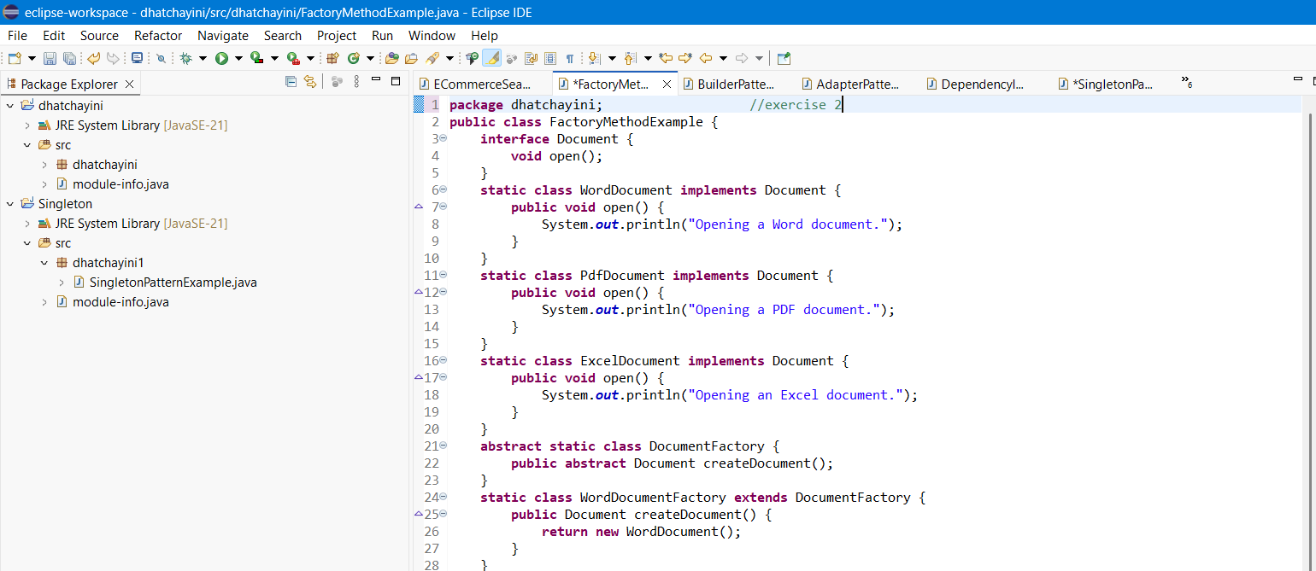

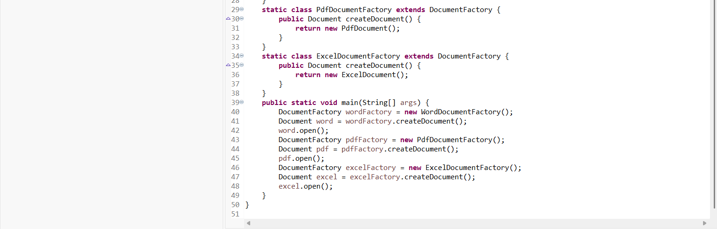

**OUTPUT:**

